Lesson plan 2: Check boxes
About the lesson
This lesson introduces students to the use of check boxes within a spreadsheet. They will learn how to insert check boxes into a spreadsheet and how to link their value to another cell so that they can be used in a function. They will then apply this learning to practical activities using the spreadsheets provided.
Learning objectives
By the end of this lesson, students will:
- be able to insert check boxes into a spreadsheet
- be able to write functions using the Boolean value returned from a check box
- have developed a spreadsheet for a specific purpose.
National Curriculum
The following subject content from the KS3 National Curriculum is included in this lesson:
- Design, use and evaluate computational abstractions that model the state and behaviour of real-world problems and physical systems
- Understand the hardware and software components that make up computer systems
- Use logical reasoning to compare the utility of alternative algorithms for the same problem
Links
The ability to write and use functions correctly in spreadsheets is needed to support the use of spreadsheets in any other subject. There are more direct links with subjects such as maths and the sciences where the same functions are likely to be used. The ability to use check boxes is also very useful when creating surveys, which may be needed for independent research-based work.
Key terminology
check box, tick box, form control, linked cell
Teaching and learning activities
Share the objectives for the lesson with students (Slide 2 of Lesson 1 presentation).
Starter
Show students an image from a questionnaire (Slide 3).
Ask students to put their hand up if they have ever filled in a questionnaire similar to this one.
Ask: Why do questionnaires include a range of answers with boxes alongside them?
So that respondents can choose their answers from a list.
Ask: Why is this helpful to the person creating the questionnaire?
They can limit the responses which helps them analyse the data more easily. If the respondent could write whatever they wanted, someone would have to read through every response and organise the answers into themes which would be very time consuming.
Remind students that in the last lesson they created drop-down lists, which enabled the user to select one item from a list. However, sometimes we may want the user to be able to choose more than one item.
Part 1
Explain that check boxes allow the user to choose more than one item from a list (Slide 4 and page 80).
Demonstrate how to create check boxes (Slide 5 plus Video 2.1 (Excel) or Slide 6 plus Video 2.1 (Google Sheets) and page 80).
Introduce Activity 2.1: Pizza ordering system to students (Slide 7 and page 80).
Ask students to complete Activity 2.1: Pizza orders (Part 1) (Slide 8, Excel workbook 2, sheet 1/Excel workbook 2.1; Google Sheets workbook 2, sheet 1/Google Sheets workbook 2.1).
Common misconceptions
Students may believe that they can speed up the development process by copying and pasting check boxes. However, this will be problematic if the check box has already been linked to a cell in Excel. Encourage students to create all of the check boxes required and then link each one in turn to an appropriate cell. This is not a problem in Google Sheets.
It is recommended that an empty row is left between each topping to facilitate moving and handling the check boxes.
Answer
Microsoft Excel:
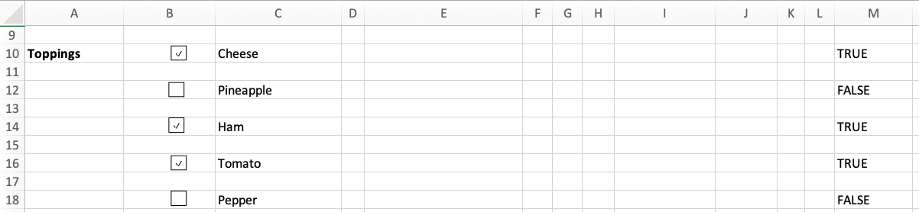
- Make sure that each check box is linked to the cell in column M in the same row.
- Note that if a check box is not selected when the cell link is created, the value in the linked cell will not show. Encourage students to select and then unselect the check boxes to confirm that the value in column M changes correctly.
Google Sheets:
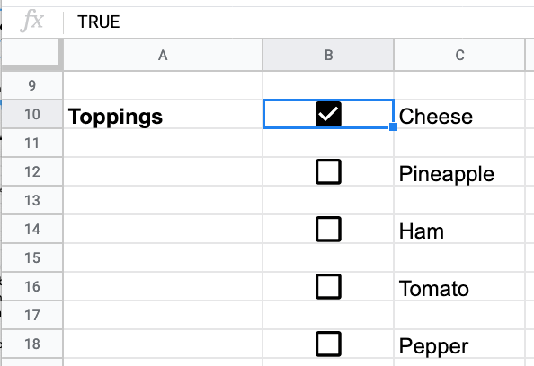
Part 2
Demonstrate how to use the Boolean value linked to a check box in an IF function (Slide 9 plus Video 2.2 (Excel) or Slide 10 plus Video 2.2 (Google Sheets) and page 80).
Ask students to complete Activity 2.1: Pizza orders (Part 2) (Excel workbook 2, sheet 1/Excel workbook 2.1; Google Sheets workbook 2, sheet 1/Google Sheets workbook 2.1).
- A model layout for the pizza ordering system is provided on Slide 12 (Excel) and Slide 13 (Google Sheets) and it can be helpful to display this while students are completing the activity.
- It is recommended that all data used in <code>VLOOKUP</code>s and other functions is kept to the right-hand side of the spreadsheet and the cells where the user selects values, and the prices are displayed are kept to the left-hand side.

Example answer
Excel:
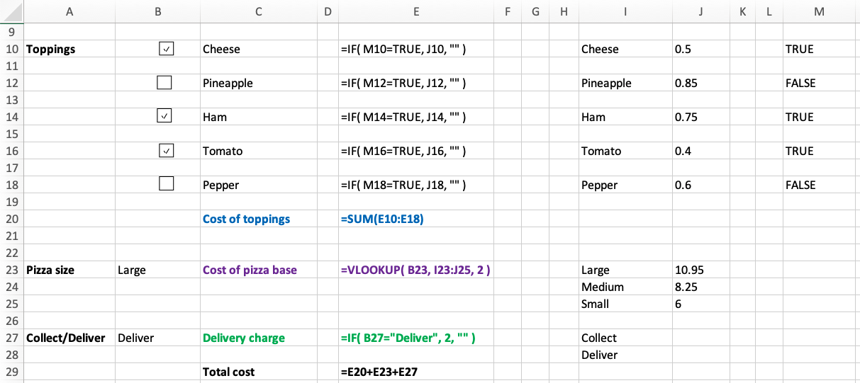
- Check that an IF function is being used to display the cost of each topping it has been selected.
- For example (Excel): =IF( M10=TRUE, J10, "" )
- For example (Google Sheets): =IF( B10=TRUE, J10, "" )
- If the topping has not been selected, the cell should either show £0.00 or remain blank.
- Look for the use of the SUM function to calculate the total cost of the toppings.
- Make sure that the list of pizza sizes is in alphabetical order before the drop-down list is created.
- Check that a VLOOKUP function is being used to display the cost of the chosen pizza size. For example: =VLOOKUP( B23, I23:J25, 2). Make sure that the correct cells are being referenced in the function.
- Make sure that the list for the collect and deliver options is in alphabetical order before the drop-down list is created.
- Look for the use of an IF function to display the charge if the delivery option is chosen. For example: =IF( B27="Deliver", 2, 0 ).
- Look for the use of a formula to add together the cost of the toppings, pizza base and delivery charge to calculate the total cost. For example: =E20+E23+E27)

Plenary
Check students’ knowledge and understanding with a short question and answer session linked to the learning objectives for the lesson.
- How many values can be selected from a drop-down list?
(Answer: one)
- What form control do we use if we want the user to be able to select one or more options?
(Answer: check boxes)
- What value does a check box return if it has been selected?
(Answer: TRUE)
- Where is this value stored?
(Answer: In a cell linked to the check box.)
Homework
Ask students to complete work they did not finish during the lesson.
Ask students to complete Quiz 2.
Stretch activities
Students who complete the activities in this lesson quickly using Microsoft Excel could be encouraged to find out about option buttons and to consider where they might be used in a spreadsheet.
Support activities
Some students may struggle with linking check boxes to a cell in Microsoft Excel. These students should be encouraged to choose a cell that is adjacent to the check box, perhaps to the left-hand side. This should help them to see clearly the Boolean value changing between True and False when the box is checked and unchecked. Encourage them to get one check box fully functional before adding additional ones to their spreadsheet.
A number of short and informative videos can be found online that demonstrate the use of check boxes in Excel, such as https://www.youtube.com/watch?v=UV0j9wmDKz4

